Copyright Form
Manuscript Title: ……………………………………………………………………………………………
- I/we hereby declare that the material being presented by me in this manuscript is our original work and does not contain or include material taken from other copyrighted sources.
- I/we have not sent the manuscript or any manuscript substantially the same as the enclosed one, for publication anywhere else.
- I Commitment to the general secretariat and publication ethics in writing the manuscript.
- I understand that the Editor-in-Chief may transfer the copyright to a publisher at his discretion and have the right to use the manuscript in any form.
- I Commitment to paying the full publication fees if the manuscript is accepted.

Corresponding Author
Full Name: Nationality:
Affiliation: Workplace:
E-Mail: Phone Number:
Signature:
Co-Authors (if any)
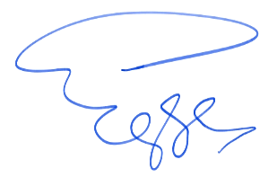
Full Name: Signature:
1-
2-
3-

Date:

